LAB 5 Task

Q1:
select count(*) as Employees_count from Employees;
select max (salary) from Employees;
select min (salary) from Employees;
select sum(salarY) from Employees;
select count(*) as Employees_count from Employees group by DEPARTMENT_ID;
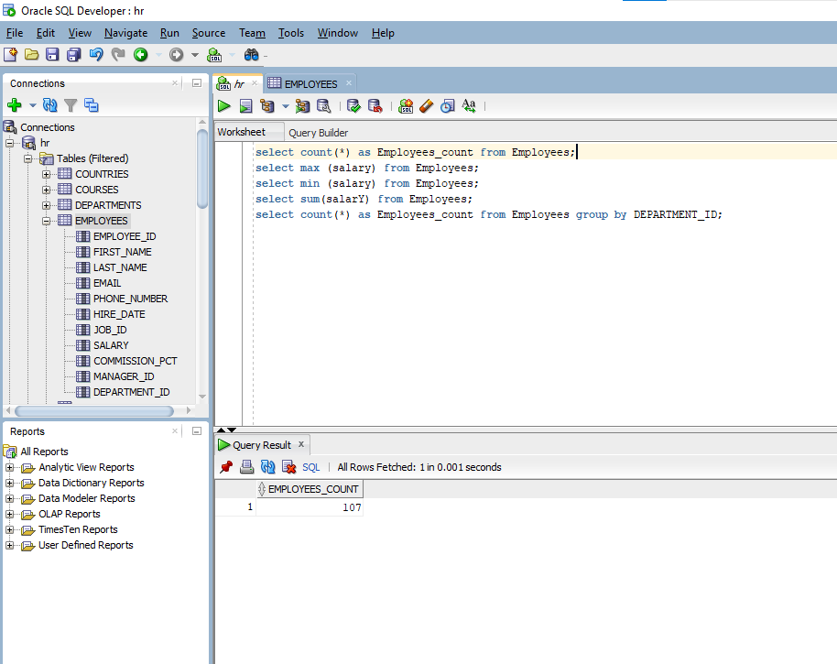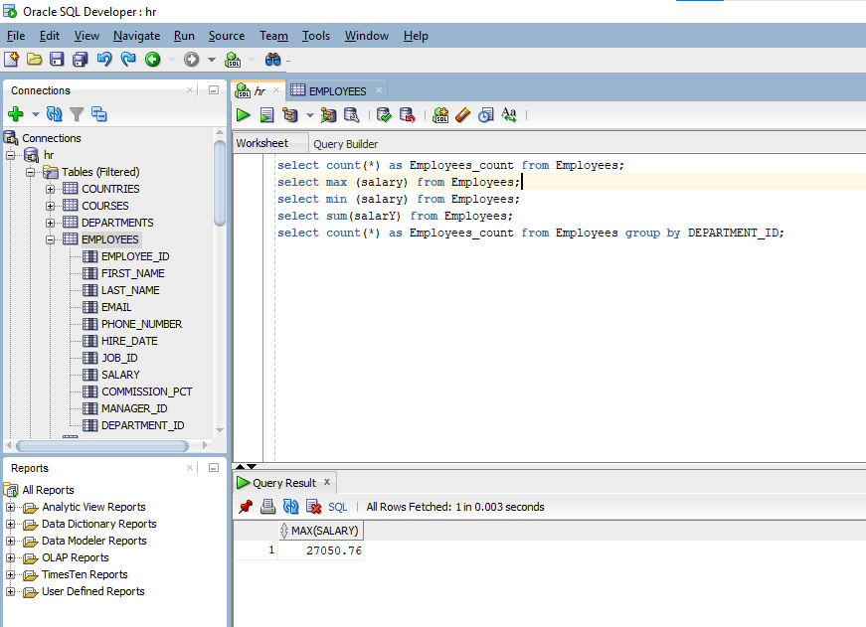
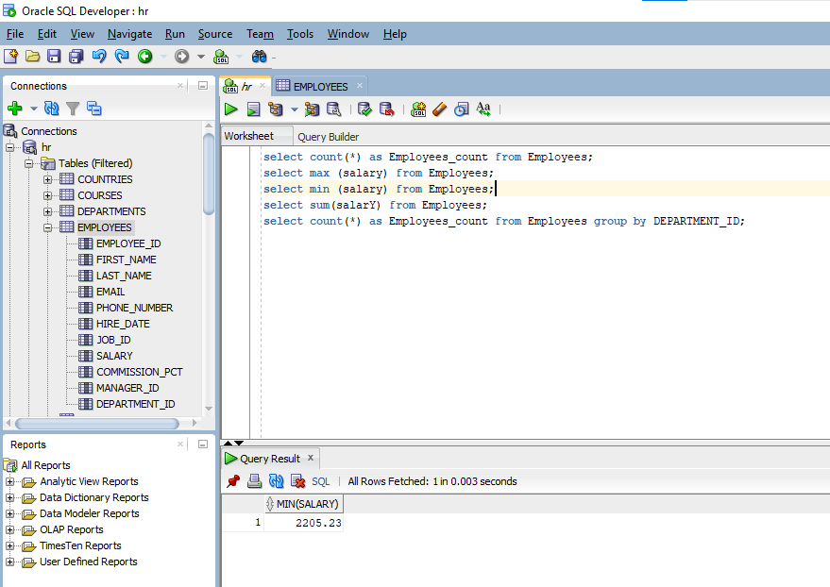
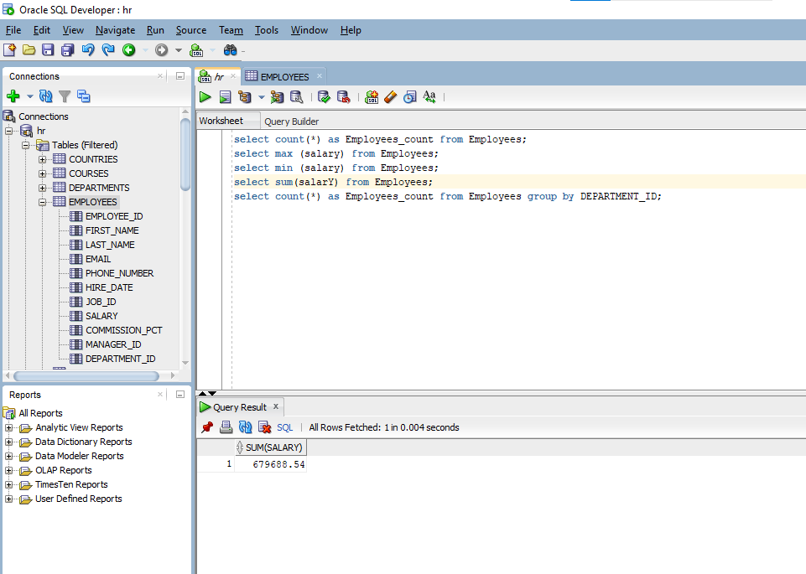
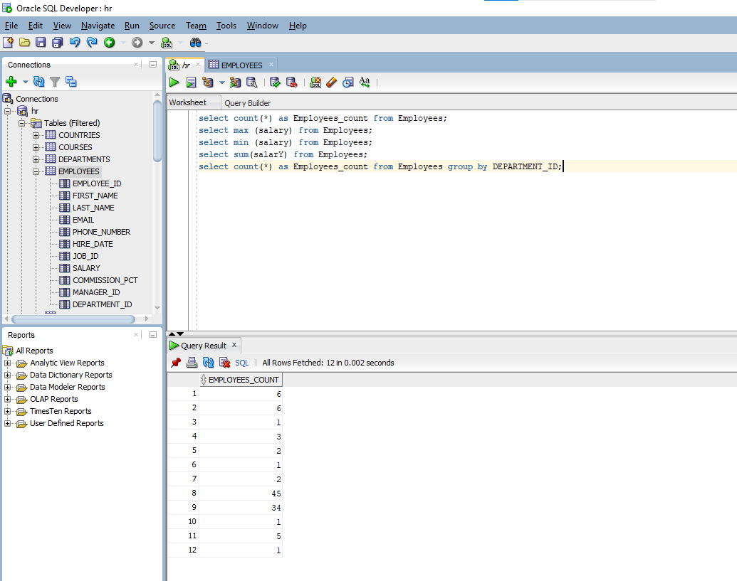

Q2:

select d.department_name, round(avg(e.salary), 2) as avg_salary from employees e
join departments d on e.department_id = d.department_id group by d.department_name order by avg_salary desc;

select d.department_name, count(e.employee_id) as employee_count from employees e
join departments d on e.department_id = d.department_id group by d.department_name having count(e.employee_id) > 5;

select department_id, sum(salary) as total_salary from employees group by department_id order by total_salary desc;

insert into departments (department_id, department_name, manager_id, location_id) values (280, 'Data Science', 100, 1700);

update employees set salary = salary * 1.05 where department_id = 50;

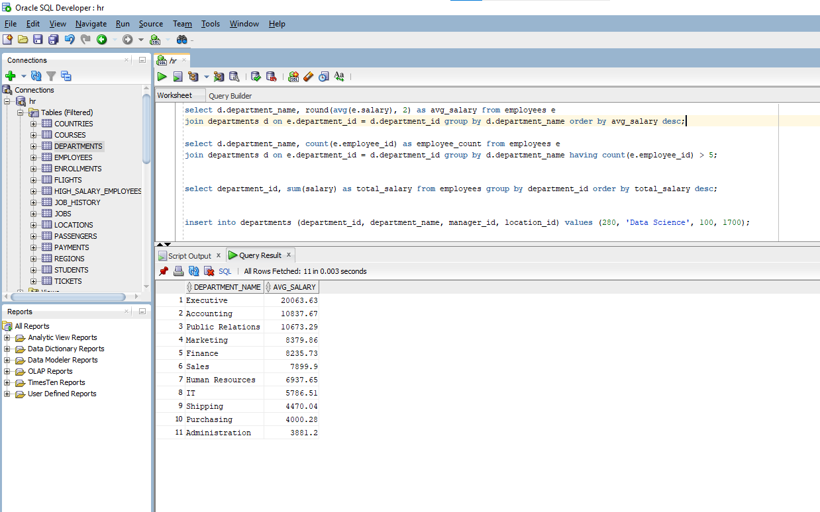
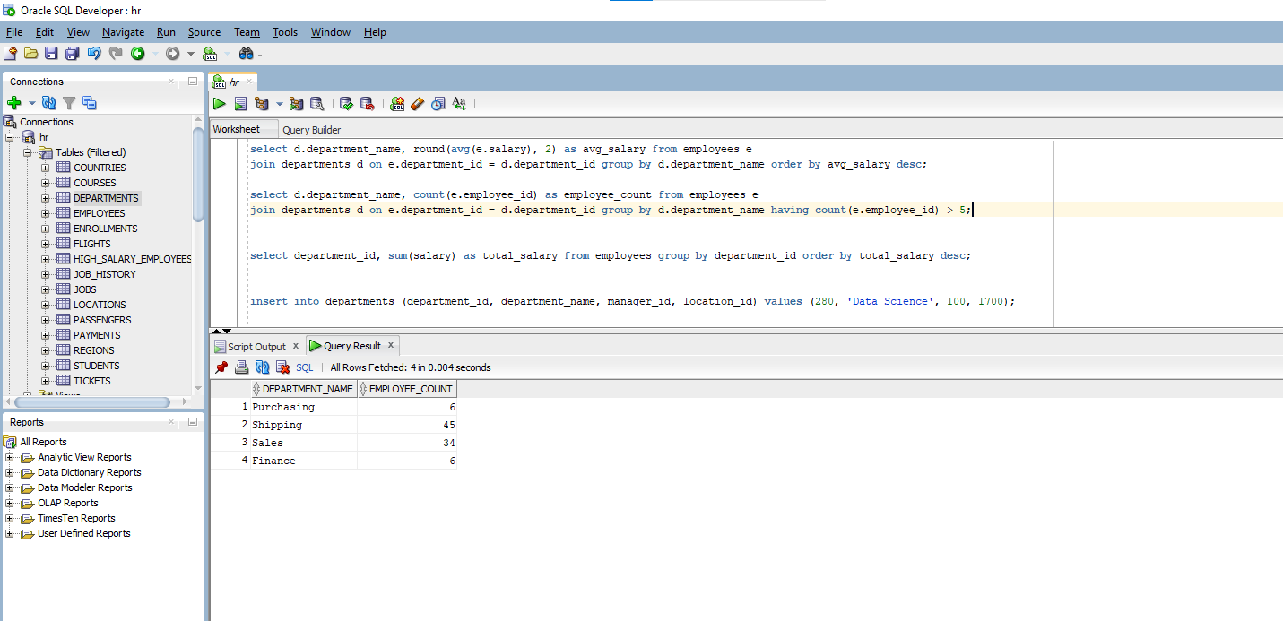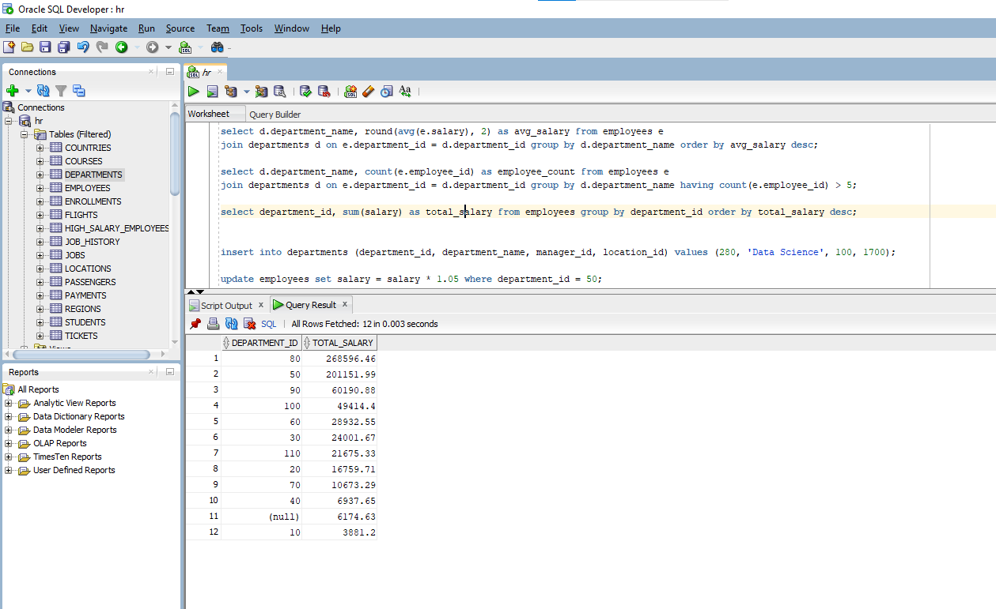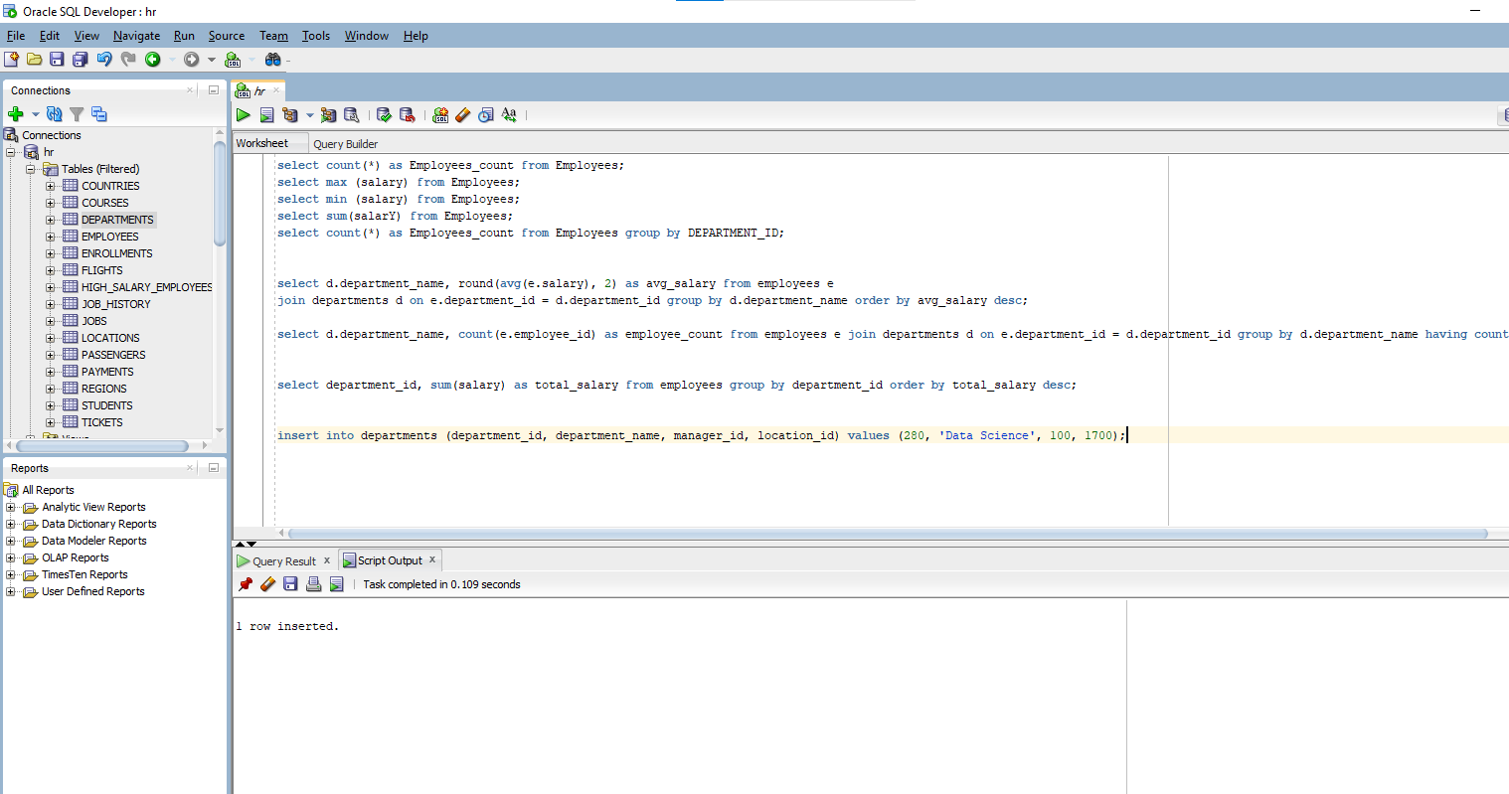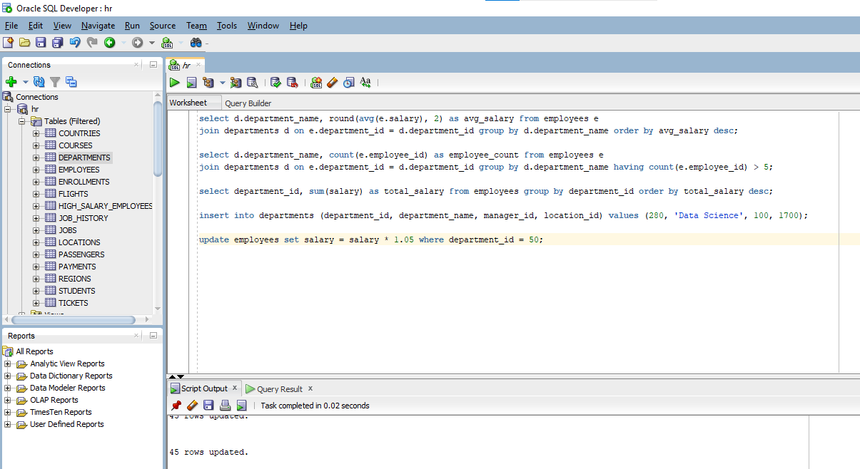

Q3:
- select department_id, sum(salary) as total_salary, avg(salary) as average_salary from employees group by department_id having avg(salary) > 7000;
- select * from departments where department_id = 280;
- select d.department_name, count(e.employee_id) from employees e join departments d on e.department_id = d.department_id where e.salary > 5000 group by d.department_name having count(e.employee_id) > 3;
- create table employees_backup_table as select * from employees;
select * from employees_backup_table;
- select department_id, avg(salary) as avg_dept_salary from employees where job_id <> 'IT_PROG' group by department_id having avg(salary) > 5000 order by avg_dept_salary desc;
